**МІНІСТЕРСТВО ОСВІТИ І НАУКИ УКРАЇНИ**

**ДЕПАРТАМЕНТ ОСВІТИ І НАУКИ**

**ДНІПРОПЕТРОВСЬКОЇ ОБЛАСНОЇ ДЕРЖАВНОЇ АДМІНІСТРАЦІЇ**

**ОРДЕНА "ЗНАК ПОШАНИ" ВИЩЕ ПРОФЕСІЙНЕ УЧИЛИЩЕ № 75**

***ЗБІРНИК ЗАВДАНЬ***

***З ТЕМИ «ПОДОРОЖ ЛІТАКОМ»***

з предмету «Англійська мова (за професійним спрямуванням)»

для студентів IV курсу

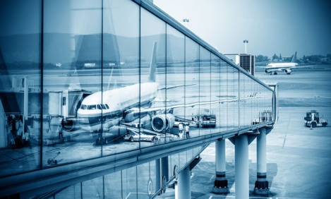

*Олександрівка, 2019*

Збірник завдань з теми «Подорож літаком» з предмету «Англійська мова (за професійним спрямуванням)» для студентів IV курсу - с. Олександрівка, 2019 р.

Укладач: **Скачко Олена Віталіївна** - викладач англійської мови «Орена «Знак пошани» ВПУ №75, спеціаліст ІІ категорії

Збірник розрахований на проведення практичних та самостійних занять з теми «Подорож літаком» із розділу «Ділова поїздка за кордон». Збірник призначений для роботи на заняттях з англійської мови з метою розвитку навичок усного, монологічного та діалогічного мовлення; читання та розуміння текстів середньої складності, розуміння прослуханих записів, у збагаченні словникового запасу та вмінні орієнтуватися у різних мовних ситуаціях.

Створюючи реальну мовну ситуацію, студенти відтворюють діалоги, які дозволять їм краще освоїтись у англомовному середовищі.

**Contents (Зміст)**

|  |  |  |
| --- | --- | --- |
|  | **TRAVELLING BY PLANE** |  |
|  | **At the Airport / В аеропорту** | 5 |
|  | **Booking and Buying Tickets / Замовлення та купівля квитків** | 7 |
|  | **On the Plane / На літаку** |  |
|  | **At the Custom's House / На митниці** | 9 |
|  | Література |  |

**AT THE AIRPORT**

**Topical vocabulary**

|  |  |
| --- | --- |
| to take a flight to ….. | летіти …. рейсом |
| carry-on luggage / baggage | ручна поклажа |
| boarding pass | посадковий талон |
| one way ticket | квиток в один напрям |
| return ticket | зворотний квиток |
| flight ….. is boarding now | здійснюється посадка на рейс … |
| departure | виліт / відправлення |
| departure gate | вихід до літака |
| departure lounge | зала очікування |
| timetable / schedule | розклад, графік |
| departures | вилети (за розкладом) |
| to announce the departure of flight | оголосити виліт літака |
| to arrive | прибувати |
| arrival | прибуття |
| to check | перевіряти |
| to check-in (for flight) | реєструватися на рейс |
| at the check-in counter | біля стійки реєстрації |
| to weigh smb’s luggage | зважити багаж |
| excess luggage | надмірна вага |
| excess luggage charge | плата за надмірну вагу |
| hand luggage | ручний багаж |
| security check | контроль служби безпеки |
| to go through … | проходити через …. |
| a sign | знак |
| to follow the signs | йти по знакам |
| duty-free zone | безмитна зона |
| luggage reclaim area / baggage claim | зона повернення багажу |
| to change planes (to transfer to another flight) | робити пересадку |
| to delay | затримувати |
| the flight is delayed | рейс затримується |
| to cancel | скасовувати |
| passport control | паспортний контроль |

**At the Airport: Useful expressions**

* 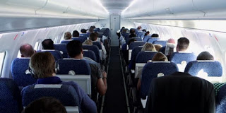**Where is the check-in desk?** – Де знаходиться стійка реєстрації?
* **I'd like an aisle/ middle/ window seat.** – Я б хотів місце біля проходу/місце посередині/місце біля ілюмінатора.
* **Could I have an aisle seat?** – Можна мені місце біля проходу?
* **Have they already announced check-in?** – Реєстрацію вже оголосили?
* **Have they already announced boarding?** – Посадку вже оголосили?
* **What gate is to the flight number ...?** – Який вихід до рейсу ... ?
* **My flight leaves from Gate 45.** – Мій рейс відправляється з виходу 45.
* **Here's my ticket.** – Ось мій квиток.
* **Here's my baggage/ luggage.** – Ось мій багаж.
* **Here's my passport.** – Ось мій паспорт.
* **This bag is my hand luggage.** – Ця сумка – моя ручна поклажа.
* **May I take this bag with me?** – Чи я можу взяти цю сумку з собою?
* **Where's the duty-free shop?** – Де магазин безмитної торгівлі?
* **Where can I get/ find ... ?** – Де я зможу придбати/ знайти ... ?
* **Are you wearing any metal?** – На Вас є що-небудь металеве?
* **Put your hand luggage over here.** – Покладіть сюди вашу ручний багаж.
* **I have nothing to declare.** – Мені нічого декларувати.
* **I went through the customs.** – Я пройшов через митний контроль.
* **You should wait in the departure lounge.** – Вам слід почекати в залі очікування.
* **Where can I get a cart?** – Де я зможу знайти візок?
* **Here's my suitcase.** – Ось моя валіза.
* **All this luggage is mine.** – Весь цей багаж мій.
* **I have three pieces of luggage.** – У мене три сумки/валізи.
* **Domestic flights are from this terminal.** – Внутрішні рейси відправляються з цього терміналу.
* **International flights are from Terminal B.** – Міжнародні рейси відправляються з терміналу Б.
* **I need to collect my luggage at the baggage reclaim.** – Мені потрібно забрати свій багаж в зоні повернення багажу.
* **Where is the flight registration?** – Де відбувається реєстрація рейсу оформлення багажу?
* **Is food served during the flight?** – Чи дається в польоті харчування?
* I would like some information about flights to Paris. – Я б хотів отримати інформацію про авіарейси в Париж.
* When does the plane depart? – Коли літак вилітає / відправляється?
* When does the plane arrive? – Коли літак прилітає / прибуває?
* The plane arrives at seven o'clock local time. – Літак прибуває о сьомій годині за місцевим часом.
* Is it a direct flight? Is it a nonstop flight? – Це прямий рейс? Це рейс без зупинки,
* How much is a business class ticket to London? – Скільки коштує квиток бізнес-класу до Лондона?
* Where is the baggage claim area? Where can I get my baggage? – Де знаходиться видача багажу? Де я можу отримати свій багаж?

**Надписи:**

**EMERGENCY EXIT**– Аварійний вихід  
**FASTEN SEAT BELTS** – Пристебніть ремені безпеки  
**FLUSH**– Змити воду (в туалеті)  
**STAFF ONLY** – Лише для персоналу  
**TOILET / LAVATORY OCCUPIED** – Туалет зайнятий  
**TOILET / LAVATORY VACANT** – Туалет вільний  
**ARRIVALS**– Прибуття  
**DEPARTURES**– Відправлення

1. Read the text and retell it.

**AT THE AIRPORT**

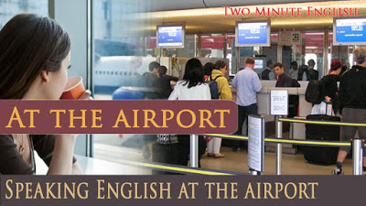Nowadays people mostly travel by air. With development of the supersonic passenger planes flying at a speed of over 800 km per hour people have got the fastest way of getting to places. Modern equipment enables safe all weather flying and even blind flying. Distances under 2000 km can now be covered by modern passenger aircraft non-stop without landing to refuel. Air travel does save time!

Here are a few hints on air travel that may be helpful:

* Most airlines have at least 2 classes of travel, first class and economy class. Economy class tickets are much less expensive.
* The rules for passengers who are traveling abroad are similar in most countries but there are, sometimes, slight differences.
* Here are some things to remember. When preparing to fly, passengers are requested to **arrive**at the airport 2 hours before **departure**time.
* At the **check-in counter** a ticket agent will look at your ticket and your passport, your luggage will be weighed on scales, checked-in, labeled, a claim-check for each piece of luggage is inserted in the ticket and sent off to be loaded into the hold of the airline. Generally this weight limit is 20 kg of checked baggage for economy class passengers and 30 kg for first class passengers. If you check **excess luggage** you'll have to pay a fee calculated by the number of extra pieces and the extra weight. Every passenger is also allowed one small **carry-on bag**, for instance a laptop computer or small suitcase, coats, umbrellas and souvenirs bought at the duty-free shops at the airport.
* Each passenger is given a **boarding pass** to be shown at the departure gate and again to the stewardess when boarding the plane. The boarding pass has a seat number written on it, number if your flight, information about your luggage. You can have a window seat or an aisle seat, the seat in the smoking section or the seat in the non-smoking section.
* You go through the security check where your carry-on luggage is searched. **At passport control** they will check your visa in case of international flying.
* After fulfilling all these formalities you go to the **departure lounge** where you can have a snack, read a paper or buy something in the duty-free shop and wait for the announcement to board the plane.
* **On board the plane** watch the electric sign flashes and listen to the announcements on the public address system. The captain will welcome you on board, tell you about the flight and the interesting places you are flying over. When “Fasten Seat Belts” sign goes on, do it promply, and also obey the “No smoking” signal.
* After landing, follow the “Arrival” signs. Make sure that you are in the right channel when you reach passport control. There is one channel for holders of European Community passports, and a second channel marked “Other Passports”.
* After passing through passport control, follow the signs to the **baggage reclaim area**. If you have luggage which was carried in the airport hold. it will be delivered to you in the baggage reclaim area. Look for the sign with your flight number. If you have only hand luggage go directly through the baggage reclaim area to customs.
* All passengers must **pass through customs** after passport control. Each country has its own **customs regulations**, which define what articles are liable to duty and what are free. Sometimes an article which falls under customs restriction and is liable to duty is allowed in duty-free is the traveler doesn’t exceed a certain fixed quota. Customs restrictions also include a prohibited articles list. This is the list of items which may not be brought into a country or taken out of it. If the traveler has any item which comes under customs restrictions he is asked to **declare** it. That is, he is asked to name the items, taking its value and other particulars. The declaration is made either orally or in writing on a special form. The passenger’s luggage is carefully gone through in order to prevent **smuggling**.

As a rule the customs officers check your passports and visas if they are required. When coming to some countries you may need a health certificate or a certificate of vaccination. He will ask every passenger the same, routine questions about whether he is carrying anything he wants **to declare**: like tobacco, alcohol, presents, and sums of money. For instance: "Have you got anything to declare?" or “Any alcohol, tobacco, presents?" The usual answers would be, "Yes, I've got some valuables, but I've put them all down in the declaration", or "I've got two blocks of cigarettes for my own use" or something of that kind. The customs officers may ask you to show your luggage to them. Usually articles for personal use and wear and also used items and gifts are not liable to duty anywhere. If you are carrying much currency you should also declare it. If you are carrying weapons you need a permit.

Occasionally the customs officers may take some of your things for a more detailed inspection but usually they return them soon.

Do not try to break the customs rules and regulations because you may have a lot of troubles.

* At the airport you may be met by a specially trained dog whose job it is to make sure that no passengers are carrying any illegal drugs. In addition, the immigration officer might want to inspect your visa, your invitation and even your return ticket.
* There is one more inconvenience you have to be prepared for when travelling long distances by plane. It's the **jet-lag**, a difference between the time you are accustomed to and the new time. At first you won't be feeling very well because of it, but don't worry - it won't take you long to get used to it.

**2. Answer the questions:**

1. Have you ever travelled by plane and if you have, how did you like it?
2. Why do people travel by plane?
3. What does a stewardess do on board a plane?
4. What do some people suffer from when flying?
5. How does the earth look lace when you are fling by plane?
6. How can you spend your time during a flight?

**3. Explain the following notions:**

international flights, prohibited articles list, domestic flights, customs duty, check-in counter, smuggling, excess luggage charge, boarding pass, carry-on luggage, duty-free shop, departure lounge, arrival card, duty-free item, customs declaration form, prohibited items, baggage reclaim area, blind landing, emergency exit, timetable, customs declaration.

**4. What the duties of:**

a pilot, a ticket agent, an air-controller, a stewardess, a customs official, a weather-man, a security officer.

**5. What can you call?**

1. The place where you go when arrive at the airport with your luggage?
2. The card they give you with the seat number on it?
3. The money you have to pay if your luggage is very heavy?
4. The place where you sit and have a drink when you are waiting for your flight to be called?
5. The bags you carry onto the plane with you?
6. The place above your head where you can put your hand luggage?
7. The part of the airport where the plane accelerates and takes off?
8. The people who look after you on the plane?
9. The part of the airport you walk through when you arrive or depart?
10. The place where you collect your luggage after you land?

**6. Read the text:**

**AT THE AIPORT**

**Departures**

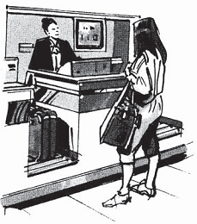This is the usual sequence of activities when you get to the airport.

First you go to the **check-in desk** where they **weigh your luggage**. Usually you are permitted 20 kilos, but if your bags weigh more, you may have to pay **excess baggage** (=you pay extra). The airline representative **checks** your ticket and gives you boarding pass for the plane with your seat number on it. Then you go through passport control where an official **checks your passport**, and go into **departure lounge**. Here, you can also buy things in the **duty-free**. About half an hour or forty minutes before **take-off**, you are told to go to a gate number, e.g. gate 14, where you wait before you get on the plane. When you **board** (=get on) the plane, you find your seat. If you have **hand luggage**, you can put it under your seat or in the **overhead locker** above your seat.

The plane then **taxis** (=mover slowly) towards the **runway**, and when it has permission to take off, it accelerates along the runway and takes off.

*Note*: The verb **to taxi** is generally only used in this context.

**The Flight**

You may want or need to understand certain announcements; these come from the **captain** (= the pilot) or from an air steward or stewardess / cabin crew / flight attendants (= people who look after the passengers):

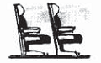

* Please **fasten your seat belt and** put your seat in the **upright position**.
* We are now **cruising** (= flying comfortably) at an **altitude** (= height) of 10,000 meters.
* May we remind passengers that there is no smoking until you are inside the **terminal building** (where the passengers arrive and depart).

**Arrival**

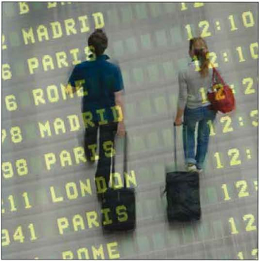When the plane **lands**, you have to wait for it to stop / come to a halt. When the doors are open, you **get off** and walk through the **terminal building** and go to the **baggage reclaim** where you collect your luggage. You then **pass through customs** (**green** = nothing to declare; **red** = goods to declare; **blue** = European Union citizens). If you are lucky, you can then get a bus, taxi or train to the city centre of town without waiting too long. You can also hire a car (= rent a car) at some airports.

**7. What do you do at the airport? Read the sentences and put them in the correct order.**

* 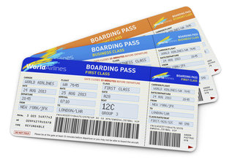You wait in the departure lounge.
* You board the plane.
* You get a cart for your luggage.
* You arrive at the airport.
* You check in your luggage and get a boarding pass.
* You go through passport control.
* 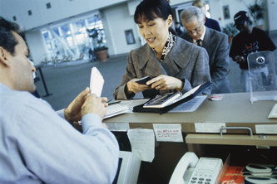You check the departures board for your number gate.



**8. Listen and repeat these useful expressions.**

**(Track 01)**

**What you ask/say**

* Where can I check in?
* Which check-in desk do I go to?
* Where’s the passport control?
* What time is the plane leaving?
* Which terminal does the plane leave from?
* Can I check my baggage in here, please?
* Where’s the nearest toilet, please?
* Do you know which boarding gate the plane is leaving from?
* Where’s boarding gate 34, please?
* Is there a baggage trolley near here, please?
* Can I check-in electronically?
* I bought this e-ticket on the Internet.
* Can I have a window seat, please?
* Can I have an aisle seat, please?
* Where’s the departure lounge, please?
* Is there anywhere I can change my money, please?

**What you hear**

* Can I see your passport, please?
* Did you pack the bags yourself?
* Will you have to pay excess baggage?
* Your plane is delayed 45 minutes.
* Would you like a window seat or an aisle seat?
* Are you travelling alone?
* Here’s your boarding card.
* You’ll be boarding at gate number 34.
* Can I see your hand luggage, please?
* The plane is due to land in approximately twenty minutes.
* The plane will take off at 14:35

**9. Complete this part of a letter about an unpleasant flight.**

Dear Tom,

I’ve just arrived in Rome but I’m still receiving from a really terrible flight. We (1) ___________ two hours late because of bad weather, and then over the channel we hit more bad weather. The (2)__________ announced that we had to (3)_____________ our seat belts, which was a bit worrying, and for half an hour we (4)____________ through a terrible storm. It was still raining and very windy when we (5)__________ in Rome and I was really glad to (6)_______________ the plane and get into the airport building.

Fortunately, this have improved since then but I really hope the return (7)_________ will be a lot better.

**10. Translate the sentences.**

1. You should **check in** two hours before a **flight**.
2. Passengers must show their **boarding passes** before they can get on the plane.
3. The plane will **take off** at 10:50.
4. Would all passengers please **fasten** their seatbelts as the airplane is about to land.
5. Passengers seated in rows 29 and 39 are now kindly requested to **board** a plane.
6. We will **miss** a train if you don’t hurry up!
7. You need to get in the queue to **go through the passport control**.
8. We will **arrive** in Barcelona at 7 o’clock in the morning.
9. Our ferry will **depart** from Stand 47.
10. Ton bought **a one-way** ticket to London because he didn’t know when he would return.
11. Our departure was **delayed** because of a snowstorm.
12. We **missed our flight** and had to stay overnight in an airport hotel.
13. The airport was filled with anxious people hoping **to get on home flights**.
14. At the airport it was difficult to distinguish the **departing** travelers from the **arriving** ones.

**AIRPORT SIGNS**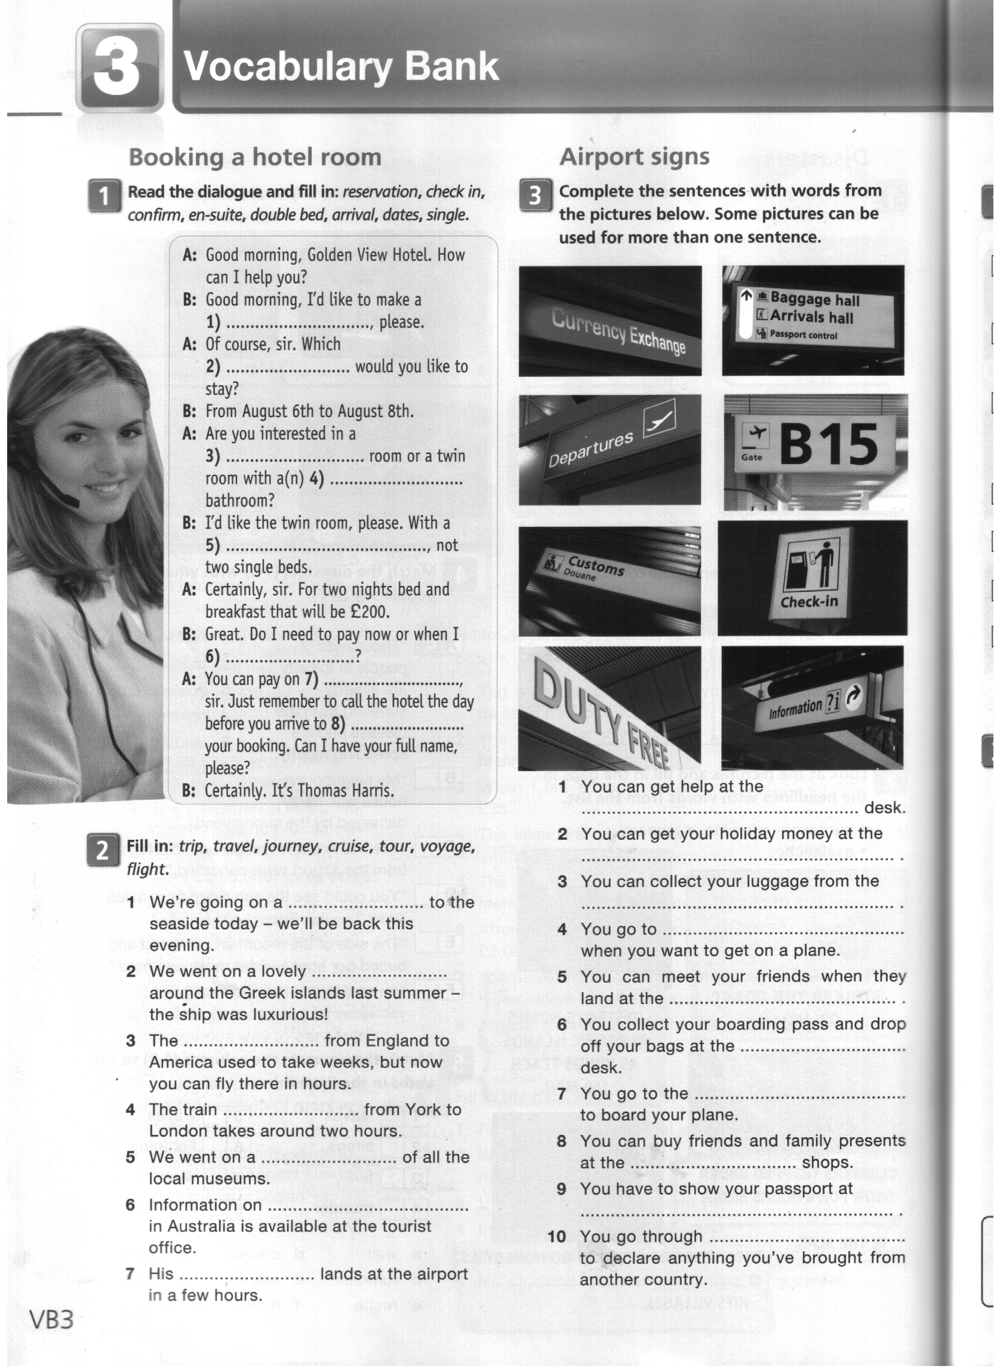

**11. Complete the sentences with words from the pictures on the right. Some pictures can be used for more than one sentence.**

1. You can get help at the ………… desk.
2. You can get your holiday money at the … .
3. You can collect your luggage from the …..
4. You go to ……… when you want to get on a plane.
5. You can meet your friends when they land at the …………. .
6. You collect your boarding pass and drop off your bags at the ……….. desk.
7. You go to the ………… to board your plane.
8. You can buy friends and family presents at the ………… shops.
9. You have to show your passport at …… .
10. You go through ……….. do declare anything you’ve brought from another country.

**12. Correctly spell the words below. The first letter of each word in underlined.**

1. Do you prefer a window seat or an (ei**a**sl) seat?
2. Do you like to take lots of (eagg**b**ag) with you when you travel?
3. Where can you get a (go**b**ardin) pass?
4. Have you ever travelled in (u**b**sssine) class on an airplane?
5. What should you bring to the aitport (k**c**ehc-ni) counter?
6. Do you like to travel in (yconom**e**) class? Why? (Why not?)
7. Why does a (s**f**irt) class ticket cost so much?
8. Would you like to be a (g**f**liht) attendant?
9. What is an airport (tea**g**) number?
10. Have you ever felt tired with (t**j**e) lag? If ‘yes’, when?
11. Do you ever talk to the (s**p**agssener) when you travel by air?
12. Do you feel nervous when the plane is going to (dan**l**)?
13. Would you like to be a (**p**oilt) and fly airlines?
14. Do you feel nervous when the plane is going to (**t**eak-fof)?
15. Why do some people prefer a (**w**owndi) seat, not an aisle seat?

**VOCABULARY PRACTICE**

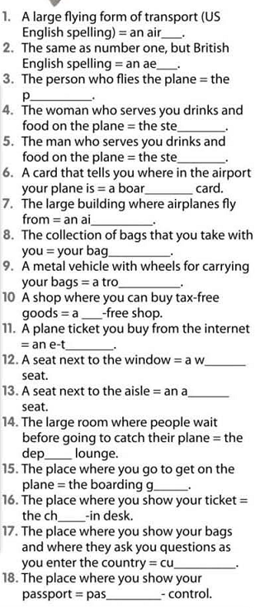



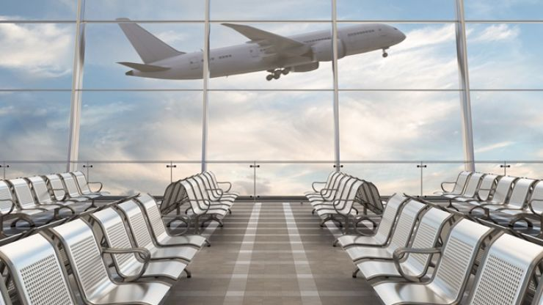



**13. See if you can identify the word. Then try to find the words in the wordsearch. Good luck!**

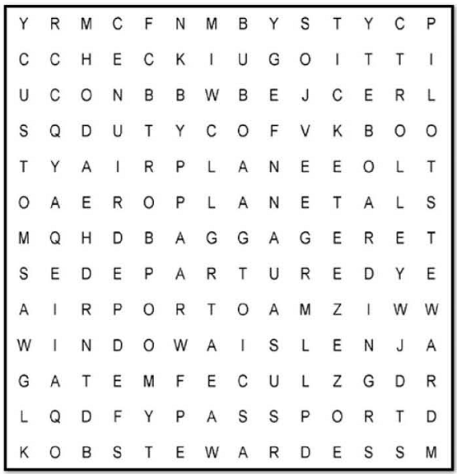

*(from Learn Hot English №139)*

**14. Fill in: terminal, gate, runway, customs, cargo, departures, arrivals, check-in, altitude, take-off, aisle, seat.**

1. The plane had to land at another airport because the …….. was covered in snow.
2. You’d better book as there is only one …….. left on that flight.
3. All the British Airways flights leave from the same ……… .
4. If you want to travel with a large pet, it has to stay in the hold with the …………….. .
5. The pilot reminded passengers to fasten their seatbelts for ………. .
6. What …………… does a passenger plane fly at?
7. There is a bus that will take you from the town centre to the …….. area of the airport.
8. The cabin crew have to walk up and down the ……… hundreds of times during the flight.
9. There were crowds of people in the …….. area waiting for loved ones.
10. You might get stopped and searched at …….. when you arrive.
11. To avoid queues at …………. you should book online and print out your boarding pass.
12. The number of the …….… from which you will depart is written on the boarding pass.

**15. Match the words to form phrases. Where can you find all these things? Use the phrases in the sentences of your own.**

1. economy
2. departure
3. excess
4. long haul
5. boarding
6. passport
7. security
8. flight
9. budget
10. conveyer
11. airline
12. guard
13. lounge
14. class
15. belt
16. luggage
17. control
18. flight
19. pass
20. attendant

**16. Match the sentences to the places.**

1. **airplane**
2. **passport control**
3. **arrivals hall**
4. **customs**
5. **check-in**
6. **departure hall**
7. How many pieces of luggage have you got?
8. Do you have anything to declare, sir?
9. Sorry, but I think you are in my seat.
10. This is the last call for passengers on flight BA1394 to Manchester.
11. Can I see you passport, please?
12. Excuse me! How do I get to the taxi stand?

**17. Choose the correct word.**

1. Takeoff was **delayed/missed** for over an hour because of bad weather.
2. We tried to **book/hire** our flight online, but we couldn’t.
3. He went on a business **trip/travel** to Chicago.
4. The flight attendant asked us to **fasten/fix** our seatbelts.
5. He got stuck in a traffic jam and **missed/lost** the flight.
6. The flight was **delayed/cancelled** because of heavy rain, so we took off two hours later.

**18. Complete the sentences with the words from the box.**

* + **aisle seat**
  + **baggage**
  + **boarding pass**
  + **business class**
  + **check in**
  + **economy class**
  + **first class**
  + **flight attendant**
  + **gate number**
  + **jet lag**
  + **land**
  + **passenger**
  + **pilot**
  + **take off**
  + **window seat**

1. A _______________ is a person who can serve food and drinks to people on an airplane.
2. Remember to show your _____________ when you board an airplane.
3. If you don’t want to spend a lot of money when you fly, you should buy an ____________ ticket.
4. When will our pane begin to fly or _______________?
5. A ________________ ticket costs the most money.
6. The person who flies a plane is a ______________ .
7. You should always ________________ one or two hours before your airplane takes off.
8. If you are travelling on an airplane, but you are not the pilot, then you are____________ .
9. If you have ____________ then you feel very tied.
10. I like ___________(s) more than aisle seats because I can see outside the plane.
11. I don’t like to carry too much ____________ when I travel.
12. I always feel great when we arrive and the plane ____________(s).
13. A window seat? No, thanks. I’d like an ___________ , please.
14. _____________ costs more than economy.
15. Our airplane leaves from _______________ 46 at 5:35 pm. Let’s hurry!

**☺ Smile!**

**Some Murphy Laws For Frequent Flyers**

* No flight ever leaves on time unless you are running late and need the delay to make the flight.
* If you are running late for a flight, it will depart from the farthest gate within the terminal.
* If you arrive very early for a flight, it inevitably will be delayed.
* Flights never leave from Gate #1 at any terminal in the world.
* If you must work on your flight, you will experience turbulence as soon as you touch pen to paper.
* The crying baby on board of your flight is always seated next to you.
* The less carry-on luggage space is available on an aircraft, the more carry-on luggage passengers will bring aboard.

**BUYING AND BOOKING TICKETS**

**Topical Vocabulary**

|  |  |
| --- | --- |
| booking-office | білетна касса |
| fare | плати за проїзд |
| return ticket | зворотний квиток |
| one-way ticket | квиток в один напрям |
| through ticket | транзитний квиток |
| to date ticket |  |

**Useful Expressions**

* **Where can I book a plane ticket?** – Де я можу забронювати квиток на літак?
* **I would like to book a flight to Paris for tomorrow**. – Я б хотів замовити.забронювати квиток на рейс до Парижу на завтра.
* **I'd like to make a reservation on the morning flight to ...** – Я б хотів забронювати квиток на ранковий рейс до …..
* **I'd like to make a reservation on a flight from New York to Boston for next Friday.** – Я б хотів забронювати квиток на рейс від Нью-Йорку до Бостона на наступну п’ятницю.
* **I'd** **like to make a reservation on Flight 5343 to Hamburg this weekend.** – Я б хотів забронювати квиток на рейс 5343 в Гамбург на ці вихідні
* **I'd like to make a round-trip reservation from New York to Chicago.** – Я б хотів забронювати квиток туди й назад із Нью-Йорка в Чикаго.
* **I'd like to confirm my reservation.** – Я б хотів підтвердити бронювання.
* **When is the nearest flight to ...?** – Коли найближчий рейс до ...?
* **Are there any flights to London tomorrow?** – Ч є на завтра рейси до Лондона?
* **Is this a direct flight?** – Це прямий рейс?
* **What airport do we land at?** – В якому аеропорту ми здійснюємо посадку?
* **I'd like to travel first/ business class.** – Я б хотів летіти першим / бізнес-класом.
* **I want to fly economy class.** – Я хочу летіти економ-класом.
* **When do I have to check in?** – Коли я повинен зареєструватися на рейс?
* **Check-in time is two hours before departure time.** – Реєстрація на рейс за дві години до вильоту.

**1. Read and translate the dialogues.**

**AIRPLANE RESERVATION – DIALOGUES**

**a)**

*Peter Senenko telephones a travel agent to make an airplane reservation.*

Agent: Can I help you?

Senenko: I want to fly to New York, and would like to make a reservation.

A.: When are you planning to fly?

S.: On Friday, the 17th of December.

A.: There are three flights to New York that day – at 7 a.m., at 2:30, and at 9 p.m. What time of day

do you want to travel?

S.: I think I’d better book a seat on the 7 a.m. flight as I need to be in New York in the morning.

A.: I can make a reservation for American Airlines, flight number 857. Do you want to travel first class or economy?

S.: Economy. How much will that be?

A.: $440.00.

S.: Are meals and refreshments served on the flight?

A.: Only a snack and beverages, sir.

S.: When does the flight arrive in New York?

A.: 9:00 a.m.

S.: Which New York airport will we be flying into?

A.: La Guardia Airport. What’s your name and address, sir?

S.: Peter Senenko, Central Hotel.

A.: And a daytime telephone number?

S.: 548-729-6246.

A.: Will you pay by credit card?

S.: No. In cash. When can I get my ticket?

A.: You can pick it up the day before your departure, or we can deliver it to your hotel.

* * *

**b)**

* Can I book a ticket to London here?
* Yes, you can, Madame. Which flight?
* I think eight two one will do, it's a through plane, isn't it?
* Yes, but it's all booked up. I can offer you only flight eighty two five with a stop-over in Paris.

* * *

**c)**

|  |  |  |
| --- | --- | --- |
| *Reservations clerk:* | — | Northwind Airways, good morning. May I help you? |
| *Mary Jones:* | — | Yes, do you have any flights to Sydney next Tuesday afternoon? |
| *Reservations clerk:* | — | One moment, please... Yes. There´s a flight at 16:45 and one at 18:00. |
| *Mary Jones:* | — | That´s fine. Could you tell me how much a return flight costs?  I´ll be staying three weeks. |
| *Reservations clerk:* | — | Economy, business class or first class ticket? |
| *Mary Jones:* | — | Economy, please. |
| *Reservations clerk:* | — | That would be €346. |
| *Mary Jones:* | — | OK. Could I make a reservation? |
| *Reservations clerk:* | — | Certainly. Which flight would you like? |
| *Mary Jones:* | — | The 16:45, please. |
| *Reservations clerk:* | — | Could I have your name, please? |
| *Mary Jones:* | — | My name is Mary Jones, that´s M-A-R-Y J-O-N-E-S. |
| *Reservations clerk:* | — | How would you like to pay, Ms. Jones? |
| *Mary Jones:* | — | Can I pay at the check-in desk when I pick up my ticket? |
| *Reservations clerk:* | — | Yes, but you will have to confirm this reservation at least two hours  before departure time. |
| *Mary Jones:* | — | I see. |
| *Reservations clerk:* | — | Now you have been booked, Ms. Jones. The flight leaves at 16:45,  and your arrival in Sydney will be at 9:25 a.m., local time.  The flight number is NWA 476. |
| *Mary Jones:* | — | Thank you. |

**CHECKING IN FOR A FLIGHT**



**1. Read the first two and the last two exchanges in the dialogue. Where are the speakers?**

**Listen, read and check. (Track 02)**

**A:** Good morning, can I have your ticket and your passport, please?

B: Sure. Here you are.

A: Thank you. Would you like an aisle or a window seat?

B: Aisle seat, please.

A: OK, and how many pieces of luggage are you checking in?

B: Just one suitcase.

A: Can you put it on the conveyer beltto be weighed, please?

B: Sure! I hope it’s not too heavy!

A: No, it’s fine!

A: Did you pack your bag yourself, sir?

B: Yes, I did.

A: Now this is important. Could you have a look at this sign, please? Are you carrying any of these items in your hand luggage?

B: Err… let’s see…. no, none.

A: OK, that’s fine. Here is your boarding pass. Boarding is at Gate 34 at 2:15. Enjoy your flight!

B: Thanks a lot. Bye!

**2. Read the dialogue in Ex 1. In which order is the passenger asked/told the following?**

**Number the phrases below from 1 to 7.**

* where / when to board?
* who packed his bags?
* where he would like to sit?
* to hand over his travel documents?
* to say whether he is carrying any forbidden items?
* how much luggage he has?
* where to put his suitcase?

**3. Choose the correct response.**

1. A: Can I see your passport?

B: **a)** Here you are. **b)** That’s great.

2. A: How many pieces of luggage are you checking in?

B: **a)** Put it on the conveyor belt. **b)** Just this one suitcase.

3. A: Did you pack your luggage yourself?

B: **a)** No problem. **b)** Of course.

4. A: Do you have any prohibited items in your hand luggage?

B: **a)** Alright, that’s all. **b)** No, nothing.

5. A: Would you like an aisle seat?

B: **a)** OK. Gate 73 at 3:15. **b)** No, window, please.

6. A: Enjoy your flight.

B: **a)** Here is your boarding pass. **b)** Thank you very much.

**4. Match the requests to the responses.**

**Listen and check. (Track 03)**

1. Could I have a window seat, please?
2. Would it be all right if I check in two bags?
3. Do you mind if I squeeze past you?
4. No, go ahead.
5. By all mean, sir.
6. I’m afraid only one is allowed.

**5. Read the sentences below and say what they mean in your language.**

* 1. It’s not our flight that’s been cancelled.
  2. It’s John who forgot his passport.
  3. It’s time we went through passport control.
  4. What I need now is coffee!
  5. Was it Andrew who found a really cheap flight to Moscow?
  6. Ann’s passport was expired. That’s why she got stopped at passport control.

**6. Now listen. (Track 04) Which words/syllables are emphasised? Listen again and repeat.**

**7. Listen to the speakers. (Track 05)**

**For questions 1-3, choose A, B or C.**

1. You overhear part of a conversation between a student and a travel agent. Why does the student like the idea of round-the-world ticket?

1. because the price is very good
2. because the travel agent recommends it
3. because the route is changeable

2. You hear a woman talking. How does flying make her feel?

1. nervous B. Excited C. bored

3. You hear a businessman talking about an airline. What is he disappointed about?

1. It’s not as reliable as it used to be.
2. It doesn’t provide such a quality service any more.
3. The flights have become too expensive

**8. Choose the correct response.**

1. A: Can I see your passport?

B: **a)** Here is your passport. **b)** Certainly, right away.

2. A: How many bags will you be checking in?

B: **a)** Absolutely not. **b)** Just this one.

3. A: Did you pack your luggage yourself?

B: **a)** Ok, here you are. **b)** Yes, I did.

4. A: Do you pack any of these prohibited items? in your hand luggage?

B: **a)** I see what you mean. **b)** No, I didn’t.

5. A: Would you like a window seat or an aisle seat?

B: **a)** Sure, thank you very much. **b)** Aisle, please.

6. A: Could you, please, open your bag?

B: **a)** I totally disagree with you. **b)** Yes, of course.

**9. Read, listen to the dialogue and act it out. (Track 06)**

A: Good morning! **Can I see your passport, please?**

B: Sure. **Here you are.**

A: OK. **How many pieces of luggage will you be checking in?**

B: Just one suitcase.

A: OK, **could you put it on the conveyor belt**, please?

B: Sure.

A: Did you pack your luggage yourself?

B: Yes, I did.

A: And could you just look at the poster and tell me if you’ve packed any of these **prohibited** items in your **hand luggage**, please?

B: Sure…. no, nothing.

A: OK. **Would you like a window or aisle seat?**

B: Window, please.

A: Alright, that’s all. Here are your passport and **boarding card.** Please go **to gate 27B at 12:45.Enjoy your flight.**

B: Thank you very much.

**10. a) Listen and repeat, minding the intonation. (Track 07)**

1. A: Would you mind helping me with my luggage?

B: Sure, no problem.

2. A: Could you please open your bag?

B: Yes, of course.

3. A: Would it be OK if I left my bag here for a moment?

B: I’m afraid not. That’s not allowed.

**b) Use the prompts to act out similar exchanges.**

* check in 2 bags
* tell me where the toilets are
* give me an aisle seat
* use my mobile phone

**11. Find sentences in the dialogue which mean:**

- Was it you who put your things in your suitcases?

- How many suitcases are you taking with you?

- Do you want to sit down next to the window or next to the aisle?

**12. Read and act out dialogues.**

**AT PASSPORT CONTROL**

**Immigration officer:** Good evening. Where have you come from?

**Paul Ryefield**: Bucharest, Romania.

**Immigration officer**: May I have your passport and form I-94, please?

**Paul Ryefield**: Here you are.

**Immigration officer**: What´s the nature of your visit? Business or pleasure?

**Paul Ryefield**: Pleasure. I´m visiting my relatives.

**Immigration officer**:How long are you going to stay in the United States?

**Paul Ryefield**: Three weeks.

**Immigration officer**: What is your occupation?

**Paul Ryefield:** I work as an accountant for a Romanian telecommunications company.

**Immigration officer**: Do you have a return ticket?

**Paul Ryefield**: Yes, here it is.

**Immigration officer**: That´s fine. Thanks. Enjoy your trip.

**Paul Ryefield**: Thank you.

* * *

|  |  |
| --- | --- |
| **Passport**  **Control Officer:** | Your passport, please. |
| **C:** | Here you are |
| **P.C.O.** | How long are you going to stay? |
| **C:** | I’m staying in London for 2 weeks. |
| **P.C.O.** | Your passport and visa are in order. Have a pleasant stay, sir. |
|  | * * * |
| **Official.** | Could I have your passport, please? |
| **A.** | Here you are. |
| **O.** | Where are you going? |
| **A.** | I’m going to Southampton. |
| **O.** | How long are you going to stay? |
| **A.** | I’m going to stay for 5 days. |
| **O.** | What is the purpose of your trip? |
| **A.** | My cousin invited me on her wedding. |

**Put the dialogues in a correct order**

**Checking luggage**

* Yes, you can. There is no charge for that service. Do you have your luggage here?
* Let me put a tag on your bag and give you a receipt.
* Thank you.
* Yes. This is the bag I wish to check.
* Can I check my luggage instead of carrying it on the train?

**13. Choose the correct variants to complete these instructions.**

* 1. If you decide to travel by plane, ...
  2. If you want to buy an airplane ticket at a discounted rate, ...
  3. If have an airplane ticket at a discounted rate but unable to fly for any reason, ...
  4. You can use a travel agency, ...
  5. To find the telephone number of a travel agency, ...
  6. If you want to see what different airlines have to offer, ...

1. ... you look under “Travel Agency and Bureaus” in the yellow pages of the telephone book.
2. ...you won’t be able to change your flight plans or get your money back.
3. ...you make a reservation 40 to 70 days before the day of your departure.
4. ...to find the flights that best match your budget and your plans.
5. ...it is best to make a reservation for your flight.
6. ...you should look under “Airline Companies” in the yellow pages.

**14. Read and translate.**

|  |  |
| --- | --- |
|  | **Travelling By Air** |
| **A:** | Do I check in here for Eastern Flight 179 to Houston? |
| **B:** | Do you already have your ticket? |
| **A:** | Yes. Here you are. |
| **B:** | Thank you. Can you put your luggage up in here, please? |
| **A:** | Sure. I have four suitcases. |
| **B:** | We allow only three pieces. You’ll have to pay an extra charge. |
| **A:** | Oh! Can I carry this one with me? |
| **B:** | No, I’m sorry. It won’t fit under your seat. That’s $8.00. Thank you. You can choose your seat at Gate 4. Enjoy your flight! |

|  |  |
| --- | --- |
| **C:** | (Buzz!) Excuse me! May I see the contents of your pockets? |
| **A:** | Of course. |
| **C:** | Thank you. Put everything in this container. Now go back and come through the detector again. |
| **A:** | Sure. (Buzz!) Oh wait! It must be my metal comb. Here it is. |
| **C:** | That’s fine. Put it with your other things. Now come through again. |
|  |  |
| **D:** | Hello. Are you going to Houston this morning? |
| **A:** | Yes, I am. I’d like a window seat, please. |
| **D:** | May I see your ticket? |
| **A:** | Oh, sure. Here it is. |
| **D:** | You want a window seat. Smoking or non-smoking? |
| **A:** | Non-smoking. |
| **D:** | Fine. Seat 12A. Here’s your ticket and your boarding bass. Enjoy your flight! |

**GOING THROUGH CUSTOMS**

**Topical vocabulary**

**At the customs**

|  |  |
| --- | --- |
| customs regulations | митні правила |
| customs restrictions | митні обмеження |
| at the customs | митниця |
| customs duties | мито |
| duty-free | не підлягає обкладанню митом |
| prohibited articles | товари, ввіз та вивіз яких заборонено |
| to fall under customs restrictions | попадати під обмеження |
| exceed a fixed quota | перевищувати квоту |
| to declare smth. | задекларувати (зробити заяву щодо наявності речей, які підлягають миту) |
| to allow | дозволяти |
| to prohibit | забороняти |
| to go through customs | пройти митницю |
| to smuggle smth. | провозити контрабанду |
| to fill in the customs form | заповнювати митну декларацію. |

**1. Read and find out the most frequently used speech patterns:**

* + 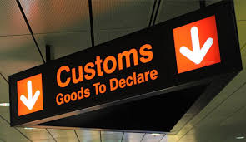Which way to customs?
  + Where do they examine the luggage?
  + Here's my passport / visa / health certificate / declaration form.
  + 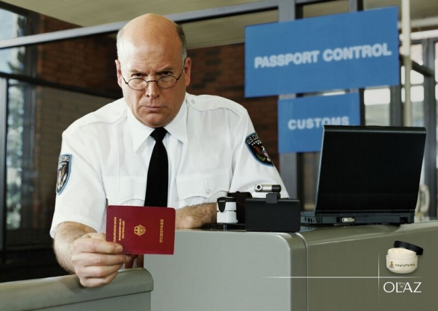Where can I get a Declaration?
  + I need a customs declaration form.
  + Who can help me fill in the form?
  + I don't know what I am allowed.
  + Are these things liable to duty?
  + Is this quantity liable to duty?
  + Do I have to pay duty on this?
  + May I bring this in?
  + How much duty must I pay?
  + I have paid the duty. Here's the receipt.
  + Here is my "Customs Declaration".
  + Have you got anything to declare? / Is there anything liable to duty?
  + I've got nothing to declare. / There is nothing liable to duty.
  + I've got only things for personal use.
  + I've got my personal belongings (effects).
  + This is for my personal use.
  + I've got several presents and souvenirs.
  + These are gifts.
  + Have you got some foreign currency?
  + Are you carrying any currency?
  + These things are duty free.
  + I have only used things and gifts.
* 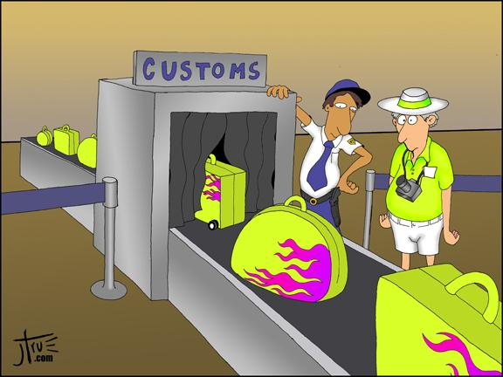***What is Customs?***

- Customs is a place where travellers' belongings are searched when leaving or entering a country.

- Customs is a building where customs are paid.

* ***What are customs?***

- Customs are taxes (duties) paid on goods, entering or leaving a country.

* ***Customs Regulations***

When you are going abroad you must get to know the customs regulations.

**2. Read and find out the necessary information about "CUSTOMS DECLARATION"**

**AT THE CUSTOM'S HOUSE**

While travelling a tourist may find himself in different places where he must both observe certain rules and enjoy his rights. Let's begin with the Custom's house. Every country has its own customs regulations which stipulate what articles are liable to duty and what articles are duty-free. Sometimes the articles liable to duty may be allowed as duty-free if the traveler does not exceed a certain fixed quota. Customs restrictions also include a list of prohibited articles. This is a list of items that may not be brought into or taken out of a country.

You have to fill in, sign and present "*CUSTOMS DECLARATION*" to the immigration and customs inspectors. There you declare items li­able to duty. If you do not know what you are allowed, then study "*THE PROHIBITED ARTICLES LIST*" and "*THE DUTY FREE QUOTA LIST."*

You pay the duty at the cashier office and get the receipt. If you do not write down some things subject (=liable) to duty, you smuggle. You have to obtain permission for duty-free importation or declare things at the Custom’s house.

If you need thing badly you must have an official paper from proper authorities giving permission to take items, which fall under special customs restriction. This paper is known as an import or export license. A traveller is asked to declare such items. It means he must name the item, state its value and often particulars. The declaration is made either orally or in writing a special form. After paying a duty the traveller is given a receipt. As a rule personal belongings are duty-free. Sometimes a passenger's luggage is carefully gone through in order to prevent smuggling. The formalities at the custom's house usually take some time. Only after passing through the customs does one realize that his journey is drawing to an end or beginning.

**3. Read and dramatize the following dialogues.**

**AT THE CUSTOMS OFFICE**

* Excuse me! Where is the customs control?
* Over there, to the left.
* Could you tell me whether used things and gifts are liable to duty?
* As far as I know, they are not.
* Oh, thanks a lot.

* * *

* Can I have your passport, sir?
* Here it is. I’m going to New York.
* How long will you stay there?
* A fortnight.
* What’s the purpose of your visit?
* Business.
* Here is your passport. Thank you. Is that your baggage?
* That big grey suitcase is mine.
* Have you anything to declare?
* I have filled in the customs declaration. There is nothing liable to duty. I have only personal things.
* O.K. That is all. Have a pleasant stay in this country.

* * *

* Where is your passport? The passport control officer is coming.
* Here it is.
* What is the purpose of your visit?
* I travel on business.
* Could you produce your visa and declaration form?
* Here they are.

* * *

* Where is your luggage, sir?
* Here it is. A suitcase and a bag. Which do you want me to open?
* Open the suitcase, please. Have you anything to de­clare?
* I don't think so. I have only articles for personal use and wear. By the way, shall I submit for inspection those PC diskettes?
* No need, sir, thank you.

* * *

* Are you British?
* No, I’m Ukrainian.
* Which flight have you just arrived on?
* From Kharkiv, Ukraine.
* Your passport, sir ... Thank you. Have you got anything to declare?
* No, I haven’t.
* You should realize that Britain imposes severe penalties for drug smuggling.
* Oh, I haven’t got anything like that.
* Would you mind opening this suitcase? What have you got in it?
* Only my personal effects ... and a box of chocolates.
* That’s fine. Thank you.

* * *

|  |  |
| --- | --- |
| **Customs Official:** | Good afternoon, madam, is this your suitcase? |
| **A:** | Yes, it’s mine. |
| **C.O.:** | Oh, I see. Have you anything to declare? |
| **A:** | Just some blocks of cigarettes for my own use. |
| **C.O.:** | No, thank you, that won’t be necessary. |

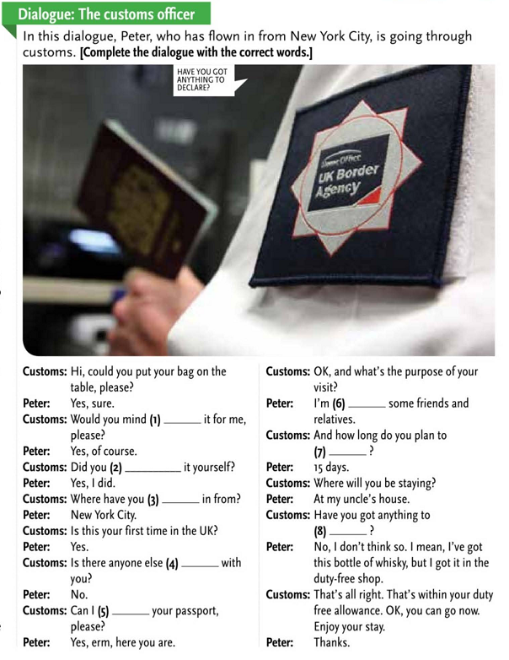**4. Listen and complete the dialogue with the correct words. (Tack 08)**

**DISCUSSION**

**5. Discuss advantages and disadvantages of air travel. Use the table.**

|  |  |
| --- | --- |
| **Advantages** | **Disadvantages** |
| speed and comfort | hijacking and terror acts |
| you cross countries and continents in just several hours | flying is too expensive |
| you are served tasty things, a variety of fruit and refreshments | planes are too fast and you don’t have time enough to acclimatize yourself to new surroundings and climate. |
| if the trip is long you are shown a movie | you get airsick |

**6. Tell what is proper or wrong to do in the following situations.**

1. You have got plenty of excess luggage.
2. Having collected your suitcases at the baggage reclaim area you find out that some of your belongings are missing.
3. At the customs you find out that you exceed the duty-free quota on cigarettes.
4. You’ve lost the key from your bag and the customs officer asks to open it.
5. You’ve misplaced your boarding pass and you are asked to show it when boarding the plane.
6. Your flight is delayed.
7. You arrive at the airport just in time to find out that your plane has taken off.
8. The in-flight meal you are offered tastes horrible.
9. The antique jewelry you are taking with you as a present to your foreign friend falls under customs restrictions and is prohibited to take out from the country.
10. Your flight is cancelled.
11. Your plane is hi-jacked.
12. In the baggage reclaim area you take by mistake somebody else’s suitcase.
13. The person sitting next to you on the plane is snoring in their sleep. You’ve got a window seat.

**7. Think about the whole experience of flying (from check-in to the time you leave the airport at your destination) and answer these questions. If possible, discuss your answers with someone else.**

1. What is the most interesting part, and what is the most boring part?
2. Where do you often have delays, and why?
3. Is there any part that frightens or worries you?
4. What do you usually do during most flights?
5. Do you always eat the food they give you?
6. Is there one thing which would improve flying and make the experience more interesting?

**8. Answer the questions:**

1. What makes air travel the most popular means of getting to places in modern world?
2. How many classes of travel do most airlines have?
3. What must one do in case on wants to go somewhere by plane?
4. Why do you have to arrive at the airport some time before your plane takes off?
5. Where do we go first at the airport?
6. Why can’t you take all your luggage to the cabin of the plane?
7. What services must you go through before getting on board the plane? Why?
8. What articles are usually liable to duty?
9. What articles are prohibited from taking into and out of the country?
10. How do you know when and where your flight is boarding?
11. How can you kill time waiting for your flight at the departure lounge?
12. Why do they destroy unattended baggage?
13. What items are prohibited on a plane? Why?
14. Why is it important to follow the instructions on the plane?
15. Need you take some food with you on board the plane?
16. In what cases do you take Green or Red channel going through customs in a destination country?

**ON THE PLANE**

**Topical vocabulary**

**Planes**

|  |  |
| --- | --- |
| airplane, aircraft | літак |
| flight | рейс, політ |
| domestic flight | внутрішній рейс |
| international flight | міжнародний рейс |
| through flight | прямий рейс |
| non-stop flight | переліт без посадки |
| long haul flight | далекий політ |
| to fly non-stop | здійснювати переліт без посадки |
| runway | злітна смуга |
| boarding ramp | трап |
| flight attendant | борт провідник |
| crew | екіпаж |
| to take off / a take off | злітати / злет |
| to land / landing | приземлятися / приземлення |
| a smooth / bumpy landing | м’яке /жорстке приземлення |
| landing gear | шасі |

**On the plane**

|  |  |
| --- | --- |
| on board the plane | в літаку / на борту літака |
| seats | місце |
| window / aisle seats | біля вікна / біля проходу |
| overhead locker |  |
| safety belts  to fasten safety belts | ремені безпеки  застібати ремені безпеки |
| to be/get air sick | страждати повітряною хворобою |
| to board the plane | сісти в літак / зійти на борт літака |
| jet lag | розлад добового біоритму в зв’язку з далеким польотом |

**1. Listen and repeat these useful expressions. (Track 09)**

**What you ask/say**

* I think this is my seat.
* Could you bring me a blanket, please?
* I think you’ve taken my seat belt.
* Could you help me put this bag in the overhead locker, please?
* There’s no more room in the overhead lockers.
* What time are we due to land?
* I’m supposed to be connecting to another flight. Do you know where I have to go?
* Excuse me. Do you have a sick bag, please?
* Do you have a any games for children?
* Can I pay in Euros?
* I’ll have a coffee/tea/coke, please?
* Do you have a vegetarian menu?
* Do you have any headphones so I can watch the film?
* That was a smooth/bumpy landing.

**What you hear**

* Can I see your boarding card, please?
* Would you like me to look after that bag for you?
* Please make sure your seat belts are fully-fastened?
* This is the captain speaking….
* Cabin staff prepare for take-off.
* Please, fasten your seat belts, fold your trays, and put your seat backs in the upright position.
* Please remain seated until the cabin lights are switched off.
* Please, switch off all mobile phones.
* What would you like to drink?
* Would you like any ice with that?
* That’ll be X euros, please.
* Would you like any duty-free goods?
* Ladies and gentlemen, we hope you’ve had a pleasant flight.

**2. Read and translate**

*“Good morning, ladies and gentlemen. This is your captain speaking. I’d like to welcome you on aboard Eastern’s Flight 179 to Houston. We’re flying at an altitude of 33,000 feet. Our speed is approximately 500 miles per hour. We’ll land in Houston in two-and-a-half hours at 1:20 local time. The temperature in Houston is 78° Fahrenheit. That’s 25° Celsius. In a few minutes you’ll be able to see the Mississippi River on the right. Our flight attendants will serve lunch in a few minutes. Enjoy your flight!”*

*(From “American Streamline”)*

**3. Complete the letter with the PAST TENSE forms of the verbs in the box.**

**My Flight to London**

*Dear, Silvia,*

**board**

**check-in**

**fasten**

**find**

**land**

**serve**

**sit**

**take**

**take-off**

**wait**

**walk**

**watch**

*Last month was my first time to fly by myself. I was a little nervous, but it was exciting! First, I (1) __________ a taxi to the international airport terminal. Then, I (2) ____________ at the check-in counter and (3) _____________ to the departure lounge at Gate 64. I was early, so I didn’t have to wait to go through immigration and security. I (4) ___________ in the departure lounge for about 25 minutes and then I showed my passport and boarding pass before I (5) ___________ the plane. After I boarded the plane, I walked along the aisle and (6) ____________ my seat, and then I (7) ____________ down and (8) _________________ my seat belt. I was lucky because my seat was a window seat, so I could look outside as the plane (9) ____________ . After a few hours, the flight attendants (10) ___________ us dinner, and then I talked to the passenger sitting next to me. His name was Leonardo, and I was surprised to find out that he was also travelling to London to study English for the summer. Finally, I (11) _____________ an action movie, and then our plane (12) ______________ soon after that. It was a great experience, and I made a lot of friends during my six weeks in England. See you soon!*

*Love, Adrianna.*

**4. Make up a story about your air travel experience. Tell it to the class.**

***Example:***

*Last week he flew to New York. It was an early-morning flight. The plane was to take off at 6 a.m. and land at 7 a.m. local time. He was stranded at the airport overnight. The plane was delayed by fog. Air passengers often suffer such delays.*

**CHECK YOURSELF**

**1. Make the words to make collocations.**

|  |  |
| --- | --- |
| * check-in * baggage * departures * cabin * departure * duty-free * conveyer * passport * air-traffic | 1. lounge/gate 2. desk 3. control 4. board 5. re-claim 6. crew 7. shop 8. control 9. belt |

**2. Fill in: check in desk, boarding pass, departure lounge, conveyor belt, departures board, duty-free shop, passport control, jet lag.**

1. When they weighed our luggage at the …………….. we were told that we had exceeded our allowance by seven kilos.
2. It took the Fullers a long time to get through ……… .
3. Our baggage will come out on …………. No.4.
4. Every time I fly from New York to London, I get really bad …………… .
5. Lisa was in the ………………. buying presents for her family when her flight was called.
6. Passengers can wait for their flight in the …………… .
7. Brian looked at the ………………. and saw that his flight was delayed.
8. Your ……. will be issued at check-in.

**3. Fill in: aisle, boarding, cabin, hand, delayed, take-off, air traffic, jet lag, short, poor.**

1. A: Hi! I heard you had a great time in America!

B: Absolutely, but it took me a day or two to recover from the ….. .

1. A: Would you like a window seat?

B: No, I’d like an ……. seat, please.

1. A: Did you manage to get a direct flight?

B: No, but it’s only a ….. stopover, so I don’t mind.

1. A: How many pieces of …….. luggage am In allowed?

B: Only one small bag, sir.

1. A: How much longer will we have to wait?

B: It shouldn’t be much longer sir, we’re just waiting for the next available ……. slot.

1. A: I heard there might be an …….. control strike.

B: Oh dear! You’d better call the airport and find out.

1. A: May I see your ….. pass, please?

B: Certainly. Here you are.

1. A: All flights are cancelled because of the fog.

B: I know. They can’t take off or land in such ….. visibility.

1. A: The …… crew are really nice, aren’t they?

B: Yes, and it makes the flight so much more enjoyable.

A: I expected you to arrive hours ago.

1. B: I’m sorry. I had a ……. flight, so I missed my connection.

**4. Translate into English:**

подорожувати у справах, замовити квиток в касі, зворотний квиток та квиток в одному напрямку, на кордоні, митниця, заповнювати митну декларацію, речі, які підлягають, митному контролю, пристебнути ремені безпеки, чекати на оголошення рейсу, сісти в літак / зійти на борт літака, місце призначення, зважити багаж, пройти через паспортний контроль, екіпаж корабля, прибути в аеропорт, перевозити зброю та наркотики